JAVA ASSIGNMENT-1

//Q1. Write a program to replace a substring inside a string with other string ?
package com.company;
import java.io.*;
import java.util.Scanner;
public class First {
public static void main(String[] args) {
String str1 = "Gunjan is frontend developer.";
System.out.println(str1);
String str2 = replaced(str1, "frontend", "Java");
System.out.println(str2);
}
public static String replaced(String str, String from, String to){
String [] arr = str.split(from);
StringBuilder result = new StringBuilder();
int i=0;
for (i=0; i < arr.length-1 ;i++){
result.append(arr[i]).append(to);
}
result.append(arr[i]);
return result.toString();
}
}
//OR
// public static void main(String[] args) {
//
// Scanner sc=new Scanner(System.in);
// System.out.println("Enter the string :");
// String str=sc.nextLine();
// System.out.println("Enter the string to be replaced :");
// String str1=sc.nextLine();
// System.out.println("Enter the string to be replaced with");
// String str2=sc.nextLine();
// String replaceStr=str.replace(str1,str2);
// System.out.println("Replaced String is ");
// System.out.println(replaceStr);
//
// }

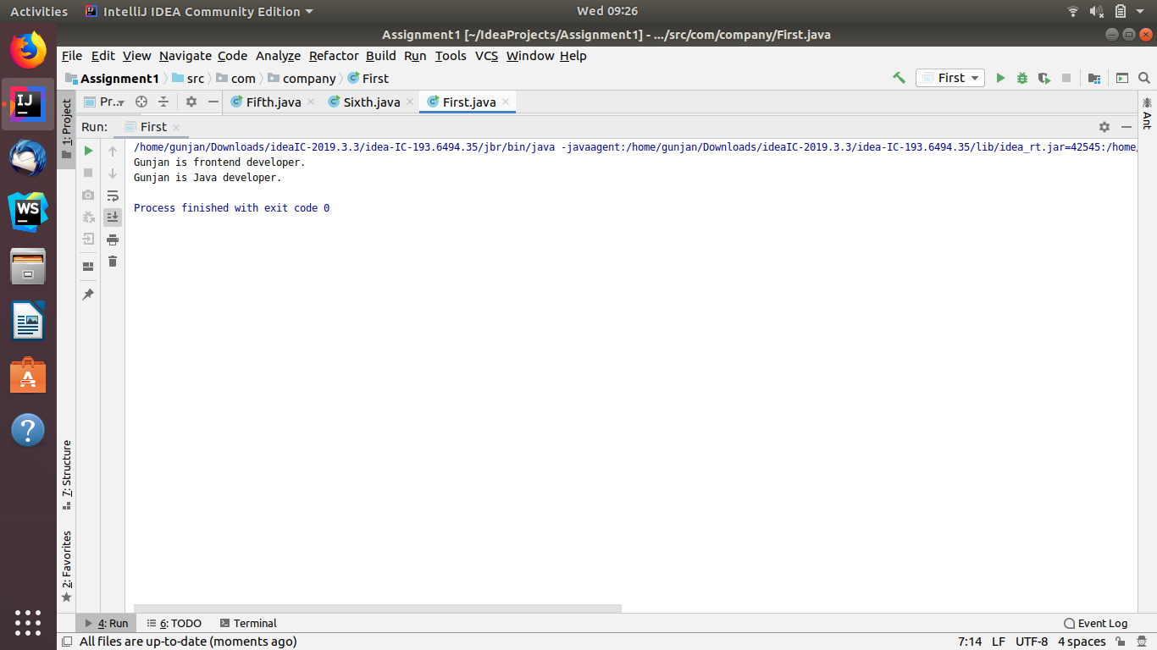

//Q2 Write a program to find the number of occurrences of the duplicate words in a string and print them ?
package com.company;
public class Second {
public static void main(String[] args) {
String str = "one one two two one two one";
String[] words = str.split(" ");
int wc = 1;
for (int i = 0; i < words.length; i++) {
for (int j = i+1; j < words.length; j++) {
if(words[i].equalsIgnoreCase(words[j]) && words[i]!="0")
{
wc = wc + 1;
words[j] = "0";
}
}
if (wc > 1) {
System.out.println(words[i]+"--"+wc);
wc=1;
}
}
}
}
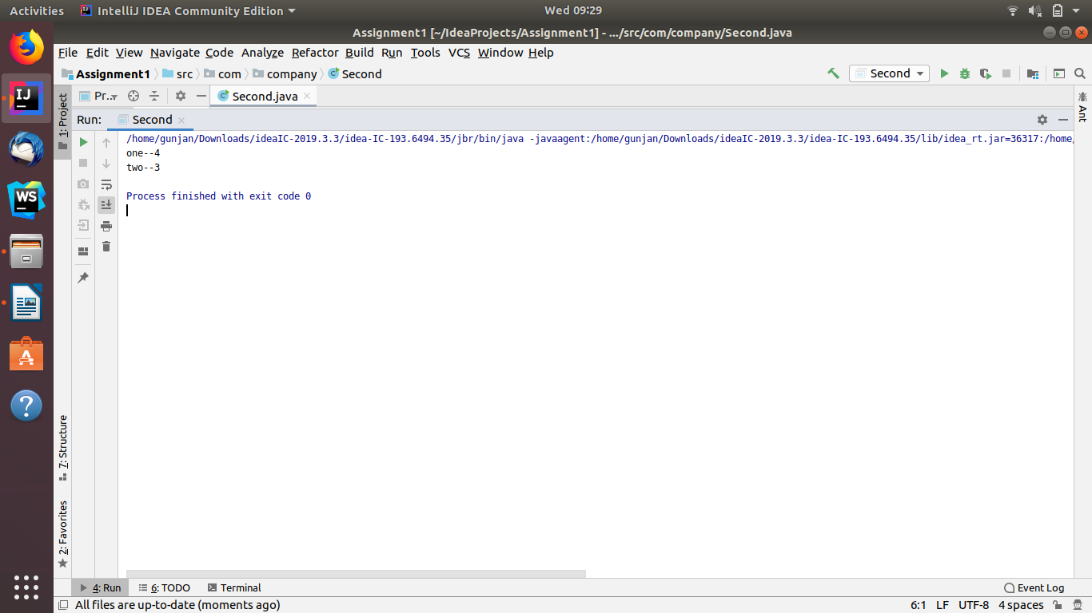

//Q3 Write a program to find the number of occurrences of a character in a string without using loop?
package com.company;
import java.util.Scanner;
public class Third {
public static void main(String[] args) {
int count=0;
Scanner sc=new Scanner(System.in);
System.out.println("Enter the String : ");
String str=sc.nextLine();
System.out.println("Enter the character to search : ");
String x=sc.nextLine();
count=str.length()-str.replace(x,"").length();
System.out.println("Number of occurence of " +x+ " is " +count);
}
}
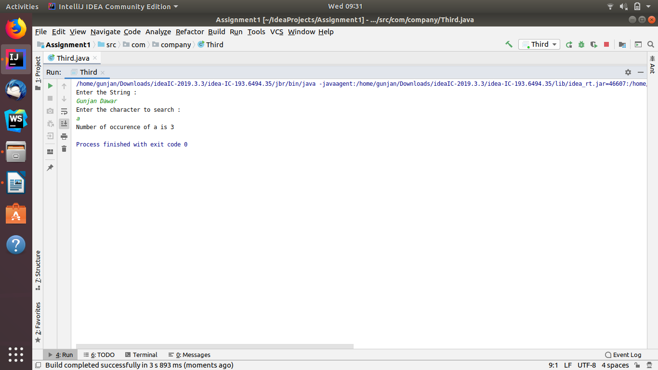

//Q4 Calculate the number & Percentage Of Lowercase Letters,Uppercase Letters, Digits And Other Special Characters In A String
package com.company;
import java.util.Scanner;
public class Fourth {
public static void main(String[] args) {
Scanner sc = new Scanner(System.in);
System.out.println("Enter the String(containing lowercase,uppercase,digits and special characters : ");
String str = sc.nextLine();
int totalchar=str.length();
int lowercase=0;
int uppercase=0;
int spclchar=0;
int digits=0;
for (int i = 0; i < str.length(); i++) {
char ch=str.charAt(i);
if (ch>='A'&&ch<='Z') {
uppercase++;
}
else if (ch>='a'&&ch<='z') {
lowercase++;
}
else if(ch>='0'&&ch<='9'){
digits++;
}
else{
spclchar++;
}
}
System.out.println("Total number of characters: "+totalchar);
System.out.println("Number of Lower case letters: "+lowercase);
System.out.println("Percentage of lower case letters: "+(lowercase*100)/totalchar);
System.out.println("Number of Uppercase letters: "+uppercase);
System.out.println("Percentage of upper case letters :"+(uppercase*100)/totalchar);
System.out.println("Number of Digits: "+digits);
System.out.println("Percentage of Digits: "+(digits*100)/totalchar);
System.out.println("Number of special Characters: "+spclchar);
System.out.println("Percentage of Special Characters :"+(spclchar*100)/totalchar);
}
}
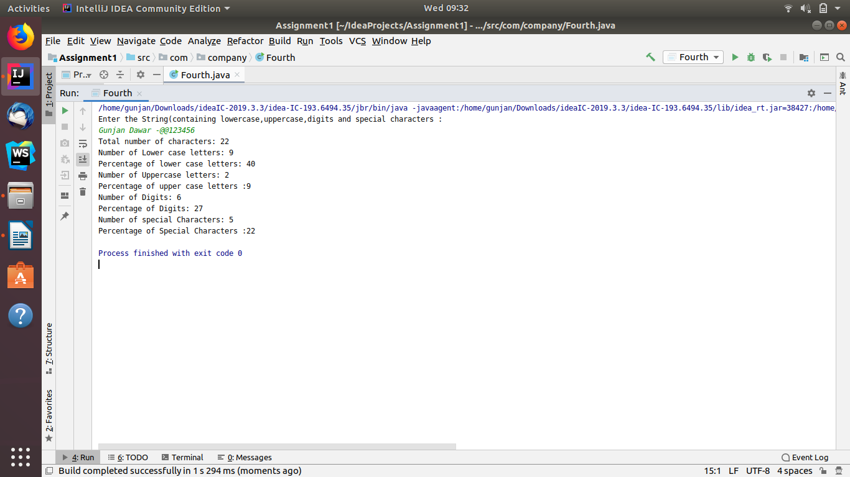

//Q5. Find common elements between two arrays.
package com.company;
import java.util.Arrays;
public class Fifth {
public static void main(String[] args) {
int arr1[] = {1, 2, 5, 4, 2, 99, 99, 4, 1, 2, 9};
int arr2[] = {2, 5, 3, 0, 1};
Arrays.sort(arr1);
System.out.println("common elements are : ");
for (int i = 0; i < arr1.length; i++) {
for (int j = 0; j < arr2.length; j++) {
if (arr1[i] == arr2[j] && i + 1 < arr1.length && arr1[i] != arr1[i + 1])
System.out.println(arr1[i]);
else if (arr1[i] == arr2[j] && i == arr1.length - 1) {
System.out.println(arr1[i]);
}
}
}
}
}

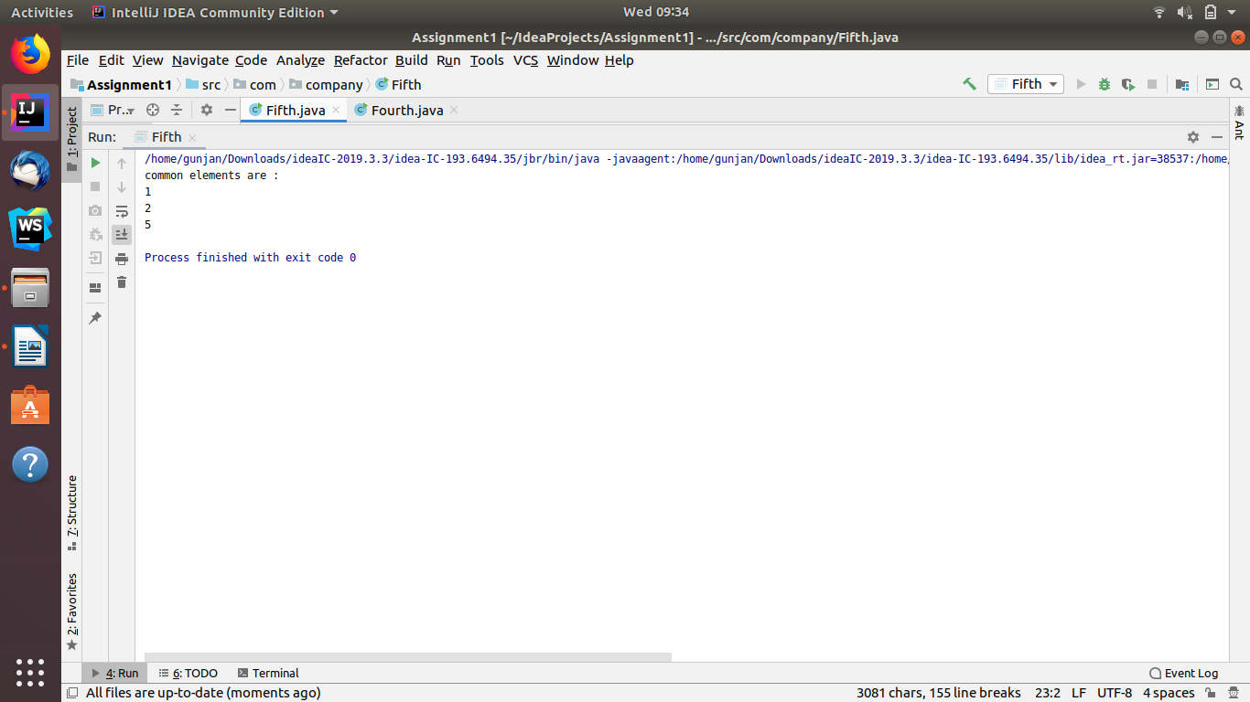

//Q6. There is an array with every element repeated twice except one. Find that element
package com.company;
public class Sixth {
static int find(int ar[], int ar_size)
{
int res = ar[0];
for (int i = 1; i < ar_size; i++)
res = res ^ ar[i];
return res;
}
public static void main (String[] args)
{
int ar[] = {2, 3, 5, 4, 5, 3, 4};
int n = ar.length;
System.out.println("Element occurring once is : " + find(ar, n));
}
}
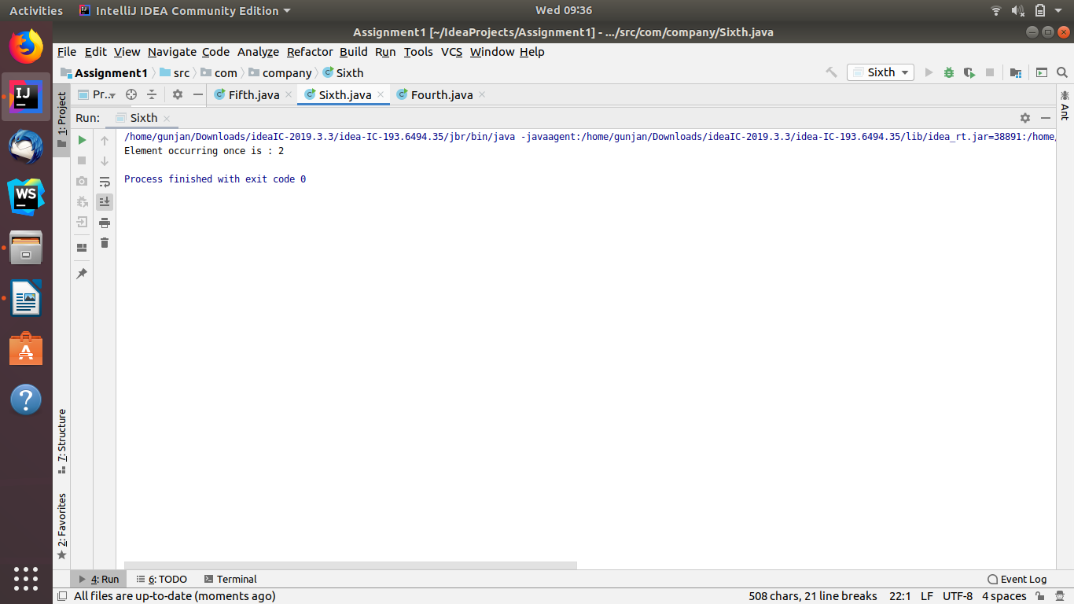

//Q7 Write a program to print your Firstname,LastName & age using static block,static method & static variable respectively
package com.company;
import java.util.Scanner;
public class Seventh {
static String firstname;
static String lastname;
static int age;
static{
Scanner sc = new Scanner(System.in);
System.out.print("Enter the Firstname: ");
firstname=sc.nextLine();
System.out.print("Enter the Lastname: ");
lastname=sc.nextLine();
System.out.print("Enter the age: ");
age=sc.nextInt();
}
static void getdetails(){
System.out.println("First Name is: "+firstname);
System.out.println("Lastname is: "+lastname);
System.out.println("Age is: "+age);
}
public static void main(String[] args) {
getdetails();
}
}
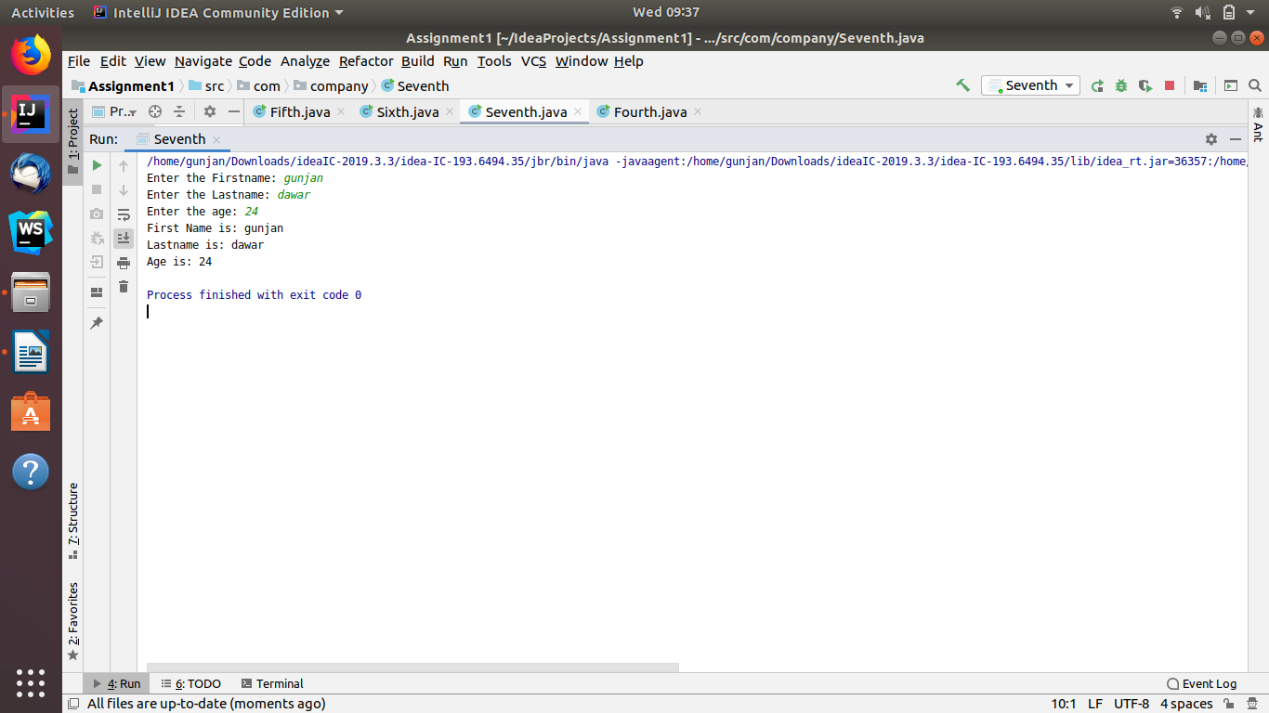

//Q8. Write a program to reverse a string and remove character from index 4 to index 9 from the reversed string using String Buffer
package com.company;
import java.util.Scanner;
public class Eighth {
public static void main(String[] args) {
StringBuilder str1 = new StringBuilder("Gunjan Dawar");
System.out.print("Reversed string is:");
System.out.println(str1.reverse());
str1.delete(4,9);
System.out.println("String after deleting characters from index 4 to index 9: " +str1);
}
}
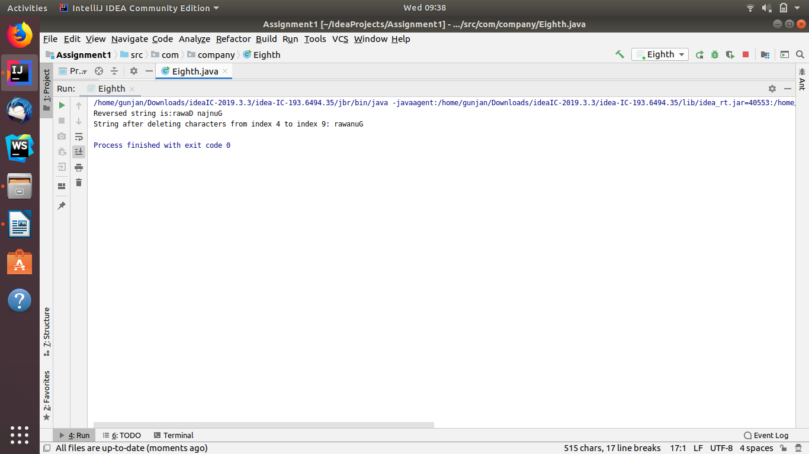

//Q9.Write a program to display values of enums using a constructor & getPrice() method (Example display house & their prices)
package com.company;
enum houses
{
house1,house2,house3,house4;
}
public class Ninth {
static houses house;
Ninth(houses house)
{
this.house=house;
}
public void getprice()
{
switch (house)
{
case house1:
{
System.out.println("price is 1000");
}
break;
case house2:
{
System.out.println("price is 2000");
}
break;
case house3:
{
System.out.println("price is 3000");
}
break;
case house4:
{
System.out.println("price is 4000");
}
break;
default:
{
System.out.println("CHOOSE CORRECT HOUSE NAME");
}
}
}
public static void main(String args[])
{
String s="house4";
Ninth n=new Ninth(house.valueOf(s));
n.getprice();
}
}
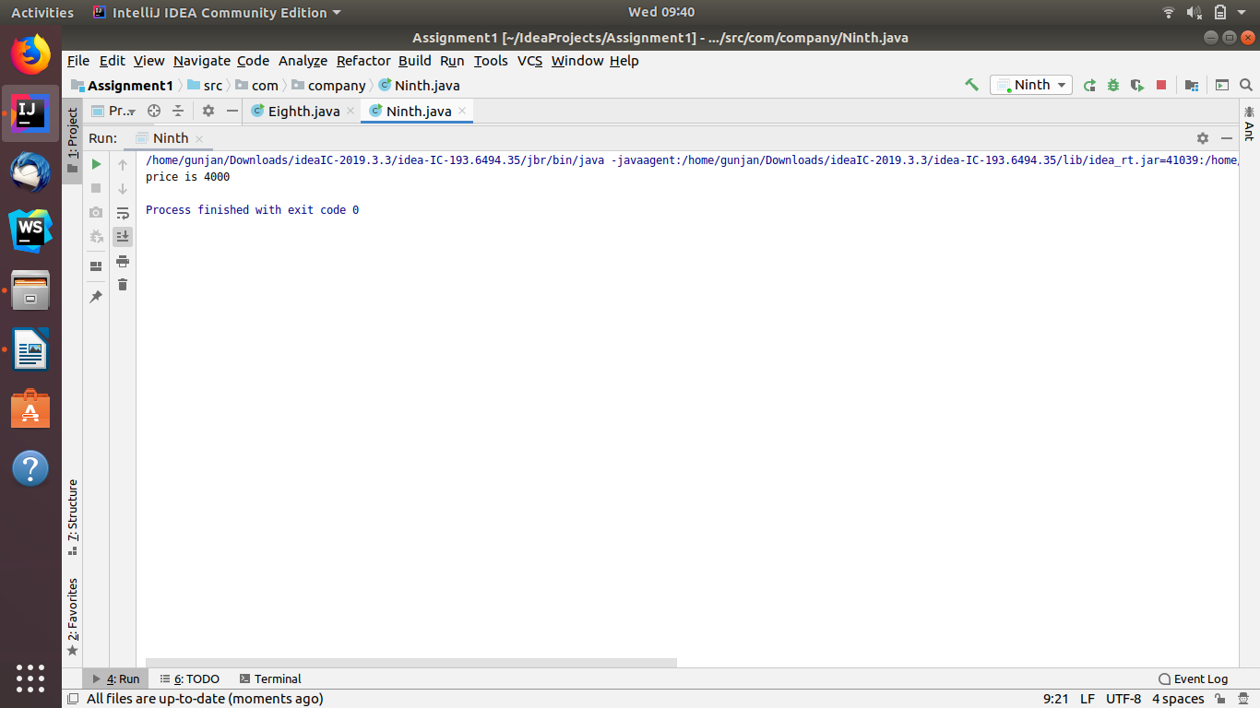

//Q10.Write a single program for following operation using overloading
// A) Adding 2 integer number
// B) Adding 2 double
// C) multiplying 2 float
// D) multiplying 2 int
// E) concate 2 string
// F) Concate 3 String
package com.company;
public class Tenth {
public int add(int a,int b){ return a+b; }
public double add(double a, double b)
{
return a+b;
}
public float multiply(float a, float b)
{
return a*b;
}
public int multiply(int a, int b) { return a*b; }
public String concat(String str1,String str2)
{
return str1+str2;
}
public String concat(String str1,String str2,String str3)
{
return str1+str2+str3;
}
public static void main(String[] args) {
Tenth obj=new Tenth();
System.out.println("Adding 2 Integer Numbers : " +obj.add(5,5));
System.out.println("Adding Two double values: " +obj.add(4.82324,2.24124));
System.out.println("Multiplying two float values : " + obj.multiply(12.7f,26.5f));
System.out.println("Multiplying two integer values : " +obj.multiply(10,10));
System.out.println("Concatenating two strings : " + obj.concat("Gunjan ","Dawar"));
System.out.println("Concatenating three strings : " +obj.concat("how ","are ","you "));
}
}
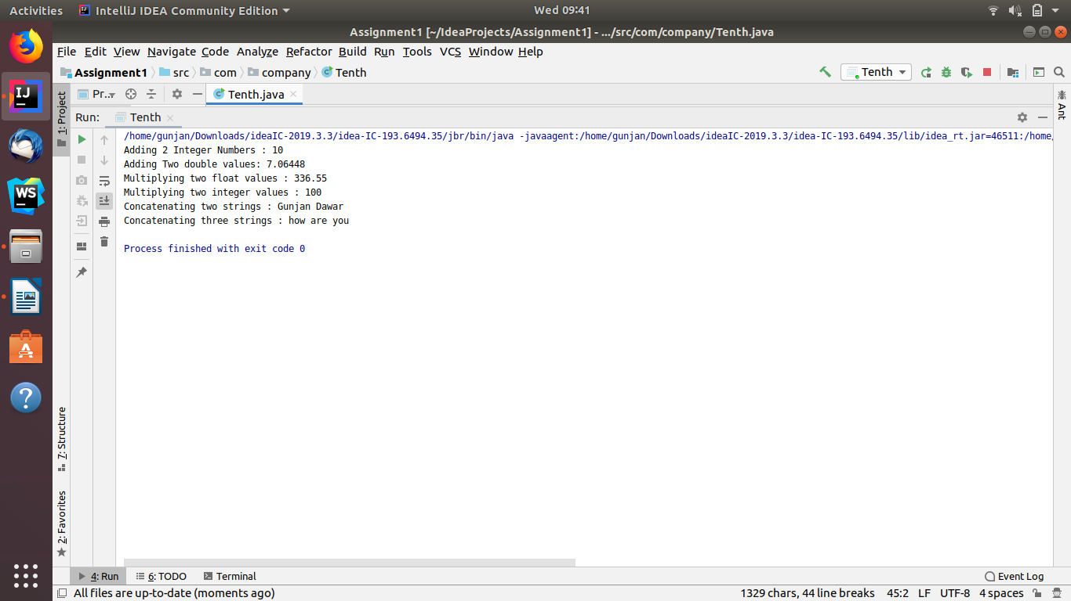

//Q11.Create 3 sub class of bank SBI,BOI,ICICI all 4 should have method
// called getDetails which provide there specific details like rateofinterest etc,print details of every banks
package com.company;
import java.util.Scanner;
public class Eleven_Bank {
Scanner sc = new Scanner(System.in);
void getDetails()
{
System.out.print("Enter Rate of interest: ");
double rateofinterest=sc.nextDouble();
System.out.print("Enter Customer Name: ");
String customer_name=sc.next();
System.out.print("Enter Ifsc: ");
String ifsc=sc.next();
System.out.println(rateofinterest);
System.out.print(customer_name+'\n');
System.out.print(ifsc+'\n');
}
class ICICI
{
void getDetails()
{
System.out.print("Enter Rate of interest ICICI: ");
double rateofinterest=sc.nextDouble();
System.out.print("customer_name ICICI: ");
String customer_name=sc.next();
System.out.print("Enter ifsc ICICI: ");
String ifsc=sc.next();
System.out.println(rateofinterest);
System.out.println(customer_name);
System.out.print(ifsc+'\n');
}
}
class SBI
{
void getDetails()
{
System.out.print("Enter Rate of interest SBI: ");
double rateofinterest=sc.nextDouble();
System.out.print("customer_name SBI: ");
String customer_name=sc.next();
System.out.print("Enter ifsc SBI: ");
String ifsc=sc.next();
System.out.println(rateofinterest);
System.out.print(customer_name+'\n');
System.out.print(ifsc+'\n');
}
}
class BOI
{
void getDetails()
{
System.out.print("Enter Rate of interest BOI: ");
double rateofinterest=sc.nextDouble();
System.out.print("customer_name BOI: ");
String customer_name=sc.next();
System.out.print("Enter ifsc BOI: ");
String ifsc=sc.next();
System.out.println(rateofinterest);
System.out.print(customer_name+'\n');
System.out.print(ifsc+'\n');
}
}
public static void main(String args[])
{
Eleven_Bank b=new Eleven_Bank();
Eleven_Bank.ICICI i = b.new ICICI();
Eleven_Bank.SBI s = b.new SBI();
Eleven_Bank.BOI bo = b.new BOI();
b.getDetails();
i.getDetails();
s.getDetails();
bo.getDetails();
}
}

